Depression: Dealing with the Soul, the Inner man
- Definitions and Explanations
  - Definitions
    - Depression
        - Secular terms
        - Biblical terms (sample)
- “Cast down” – Ps 42-43; “Bereft of peace, forgotten what happiness is… endurance has perished” – Lam 3:17-18; “Despair” (no way out) – 2 Cor 1:8-9; “Lose heart” – 2 Cor 4:1,16; Etc.
    - Soul
        - Secular
- They make some valid observations on behaviors and attempt to explain inner thoughts and motivations
- They cannot get the interpretation right or the solution right (due to being a “natural man” – 1 Cor 1-2)
        - Biblical terms – soul, spirit, heart, inner man, etc.
- Involves cognition, affections and volition
  - The mind cannot be diseased like the brain
  - The mind uses the brain but is not equal to it
  - The brain dies and the mind lives on forever
  - Explanations
    - We were created as an embodied soul (chart)
    - There is a spectrum between discouragement and depression (from common sadness to despair)
        - Often discouragement(sadness) – one continues to function
        - In despair, one typically ceases to function normally
    - It is a serious topic
    - It is a sensitive topic
    - God cares and offers us help and hope
- Any problems of the body and/or soul are a result of a broken world, sin cursed, with broken and sinful people (both sin and suffering) (Gen. 3ff; Rom. 5:12–21)
- God provides help and hope at the real/true depth of the person (Prv 4:23; Mark 7:20-23; Heb 4:12)
- Deliverance from non-organically caused depression, which is one of the effects of the fall, is made possible through the redeeming work of Jesus Christ for us (including justification and sanctification) and the work of the Holy Spirit in us within the church.
- Practical and experiential deliverance from depression and many of the other effects of the fall is not the automatic, involuntary result of regeneration and redemption (Phil. 2:12,13; Gal. 5:22,23; 1 Cor. 3:16; Phil. 2:5; 2 Cor. 4:16–18; Heb. 12:1,2; James 1:2–5).
- Believers will eventually experience complete and continuous, uninterrupted deliverance from depression and all of the other effects of the fall (1 Cor 15:50-58; Rev. 21,22; Ps. 16)

- Illustrations (2 samples from Scripture)
  - The Old Testament – example of Jeremiah in Lam 3
    - The context
    - Inaccurate and incomplete view of God (3:1-16)

    - Response of discouragement and loss of hope (3:17-18)
- Hope is lost in a ‘god’ imagined or wrongly perceived

    - His choice to ‘return’ and dwell on Truth about God (3:21)
“But this I call to mind and therefore I have hope.”

    - Perspective changed about God and revival of his faith (3:22-39)
- Hope returns in the true God revealed in His Word
  - The New Testament – example of the Apostle Paul in 2 Cor 1, 4
    - The context
        - A natural despairing of life – “no way out” (1:8-9)
        - Loss of hope (1:8)
    - The focus on Jesus in light of the New Covenant (The Gospel – the forgiveness of sins through Jesus Christ’s life, death and resurrection, chp 3-4; e.g. 3:6)
        - Realization of continuing difficult circumstances (4:8-9)
    - We are afflicted in every way – but not “crushed”
    - We are perplexed – but not “driven to despair”
    - We are persecuted – but not “forsaken”
    - Struck down – but not “destroyed”
        - Acceptance of the outer man both as ‘an instrument’ (Rom 6:13) and ‘decaying’ (2 Cor 4:16)
        - Resting on God’s power and not one’s own (4:7, c.f. 1:9)
        - Dwelling on the eternal and not focusing on the temporal (4:16-18ff)
    - He does not lose heart (4:1,16)
- Implications from God’s Word to our daily lives (GENERALLY speaking)
  - The tendency among believers to descend from discouragement into irresponsibility and eventually to despair (see chart)
    - For unbelievers (Ps 32:10; Ecc 1:14; Mat 13:18-22; Eph 2:12-13) – no true and lasting hope outside of Jesus
    - For believers (1 Ki 18-19; Mat 6:34; Jn 16:33; Rom 13:11-14; Ecc 7:13; e.g., Ruth 1:19-21; Jer 45; Mk 6:52 considering 6:7-35; 2 Cor 1:8-9)
  - How we ascend by grace into hope & trust
- We certainly would encourage a person to get a medical evaluation to see what proven organic factors might be contributing to their condition.
- The goal is not to get out of depression but to glorify God moment by moment while seeking to be faithful to Him in one’s God-given responsibilities.

    - Start with saving faith – beginning point (Eph 2:1-4; Titus 3:3-4)

    - Seek to know God and remember Him accurately by meditating on His Word and abiding in Christ (Deut 8; Jer 9; Jn 15; Rom 13:11-14; Eph 4:23; Heb 4:14-16; 2 Pt 1)

    - Strive with all diligence to exercise your faith with the spiritual disciplines (intentional and zealous pursuit) Rom 12:11;1 Tim 4:7-9; Titus 2:11-14; 2 Pt 1

    - Make specific application to your life with these truths (e.g., what 3 lessons can you learn and apply to your immediate situation?) Ja 1:22-25

    - Serve the Body of Christ (Gal 6:1-3; 1 Cor 12; 1 Jn 3:18)

    - Share Christ with others who are without hope (2 Cor 5:20; Mat 28:18-20)

- it has been said, ‘true worship of God fuels our witness.’
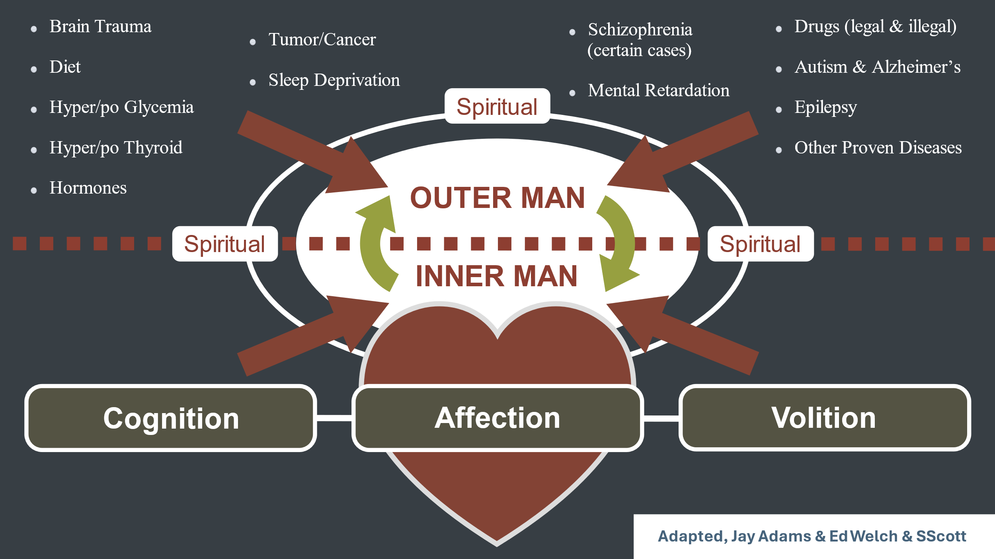

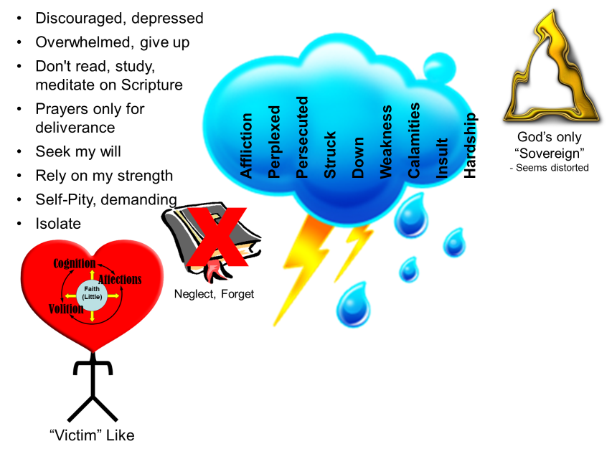
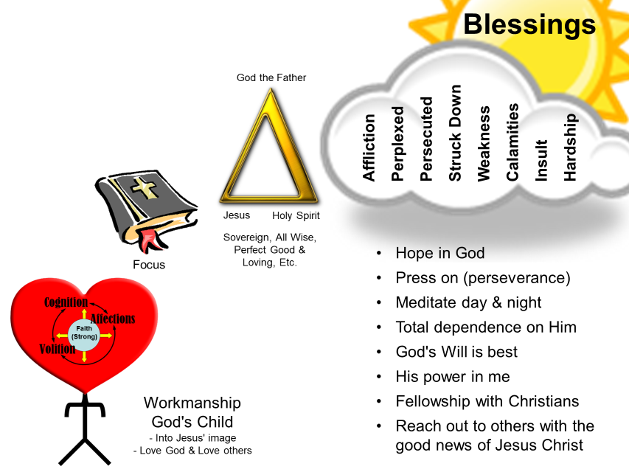

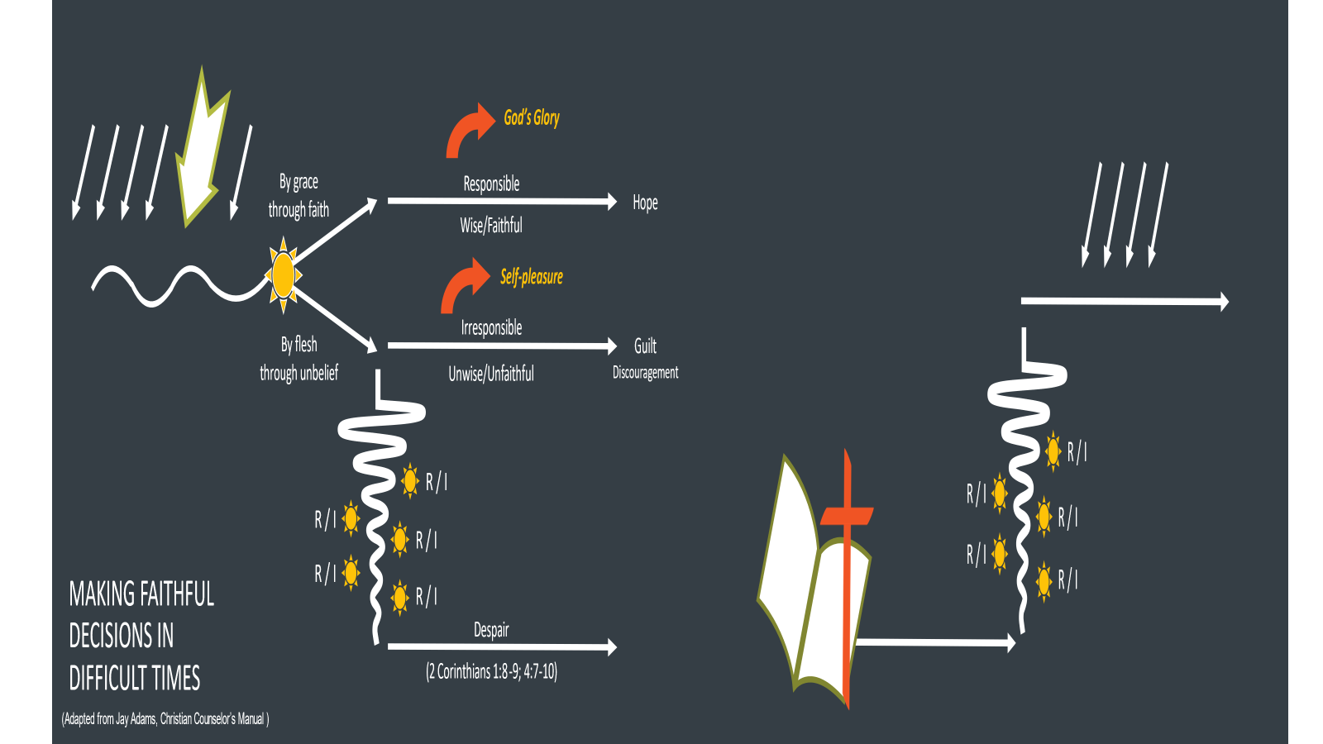

A helpful book on the spiritual discipline of biblical meditation, God’s Battle Plan for the Mind, David Saxton
A helpful read about the spiritual war we are in and Satan’s attack on our engaging in the spiritual disciplines, Joel Beeke, Fighting Satan.
A helpful resource might be to take them through the 31 Ways to be a One Another Christian, Shepherds Press

